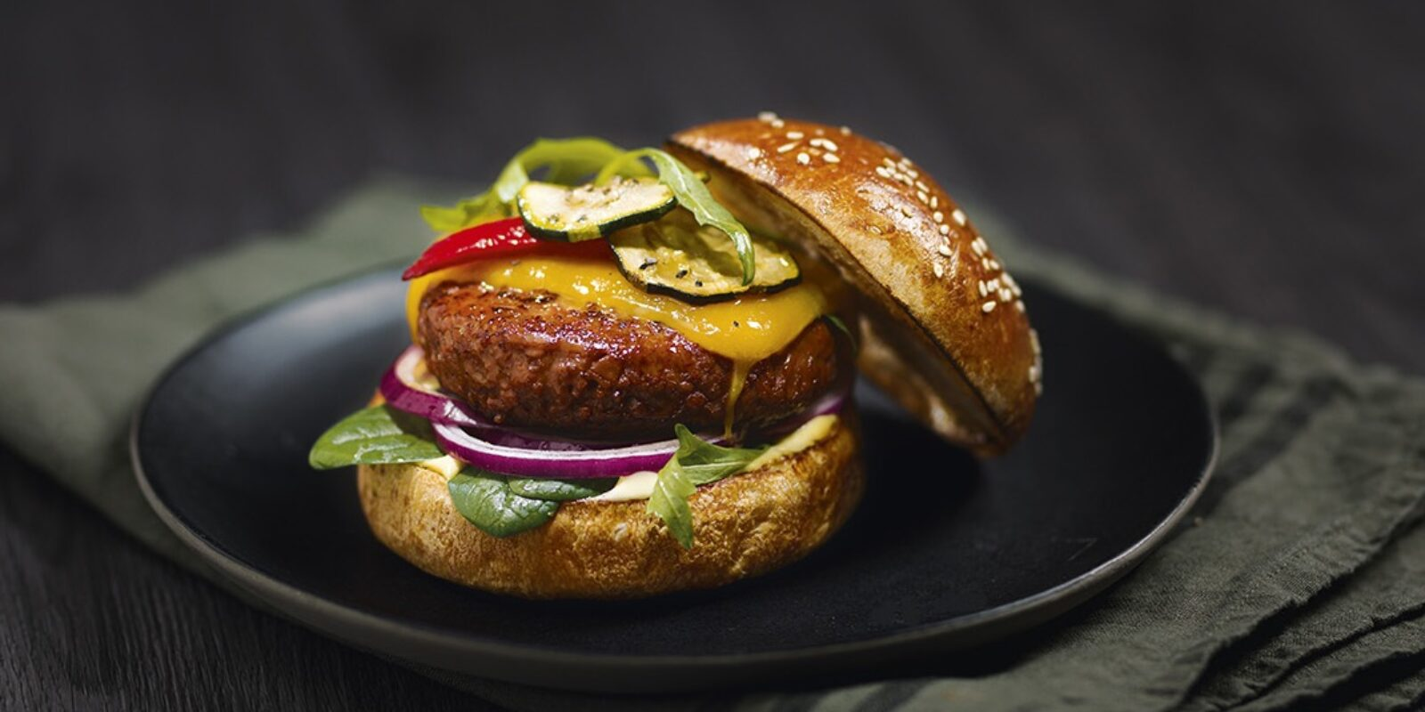**Project Category: Online Restaurant**

**Welcome to BYTE & BITE**

**Group Members:**

* Fahad Waseem
* Saboor ul Haq
* Shaheera Eman
* Areeba
* Harmain

**Course:** Application of Information and Communication Technology Lab

**Course Instructor:** Ramsha Khalid

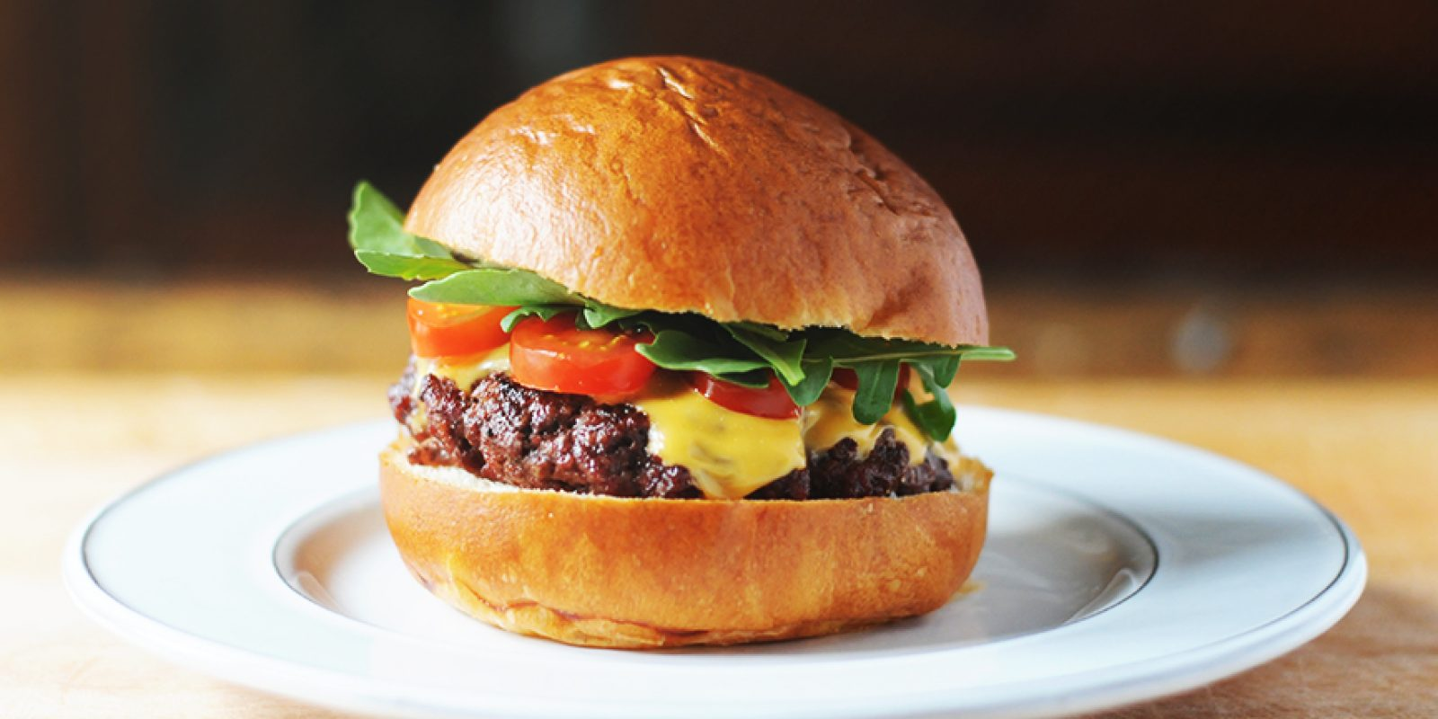

**ABOUT CATERING:**

Welcome to Byte & Bite! We are dedicated to serving delicious, freshly prepared meals that bring joy to every bite. From juicy burgers and crispy fries to flavorful pastas and refreshing beverages, our menu has something for everyone. At Byte & Bite, we combine quality ingredients, great taste, and prompt service to make every meal an enjoyable experience. Whether you’re ordering for yourself, family, or friends, we’re here to satisfy your cravings with every order.

**Executive Summary:**

The Byte & Bite Restaurant Website is a static, responsive website developed to represent a modern fast‑food restaurant brand. The site provides essential information such as the restaurant’s story, menu offerings, branch locations, and contact details in a clean and user‑friendly format. The project focuses on simplicity, clarity, and visual appeal to attract customers and provide quick access to information.

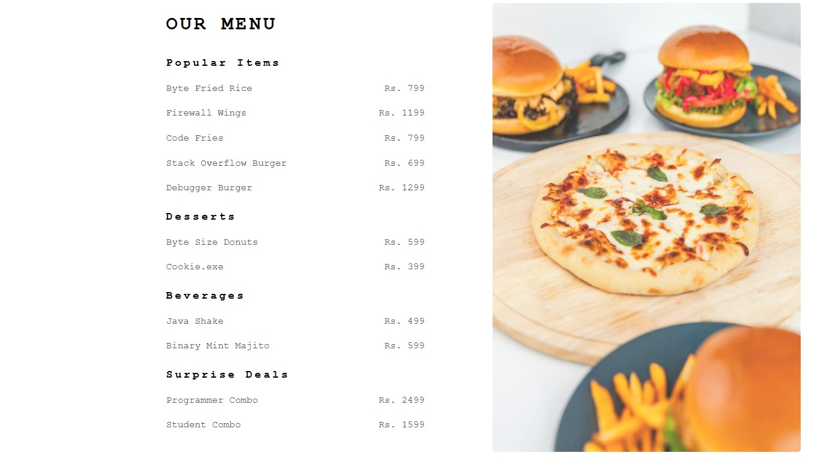

**Project Objectives & Scope**

**Objectives:**

* To provide a professional online presence for Byte & Bite.
* To showcase the restaurant menu, including popular items, desserts, beverages, and special deals.
* To provide information about branch locations and facilitate customer inquiries.
* To improve customer engagement and promote catering services.

**Scope:**

* Development of a responsive website compatible with desktop and mobile devices.
* Creation of structured sections for About, Menu, Location, and Contact.
* Integration of images and multimedia to enhance user experience.
* 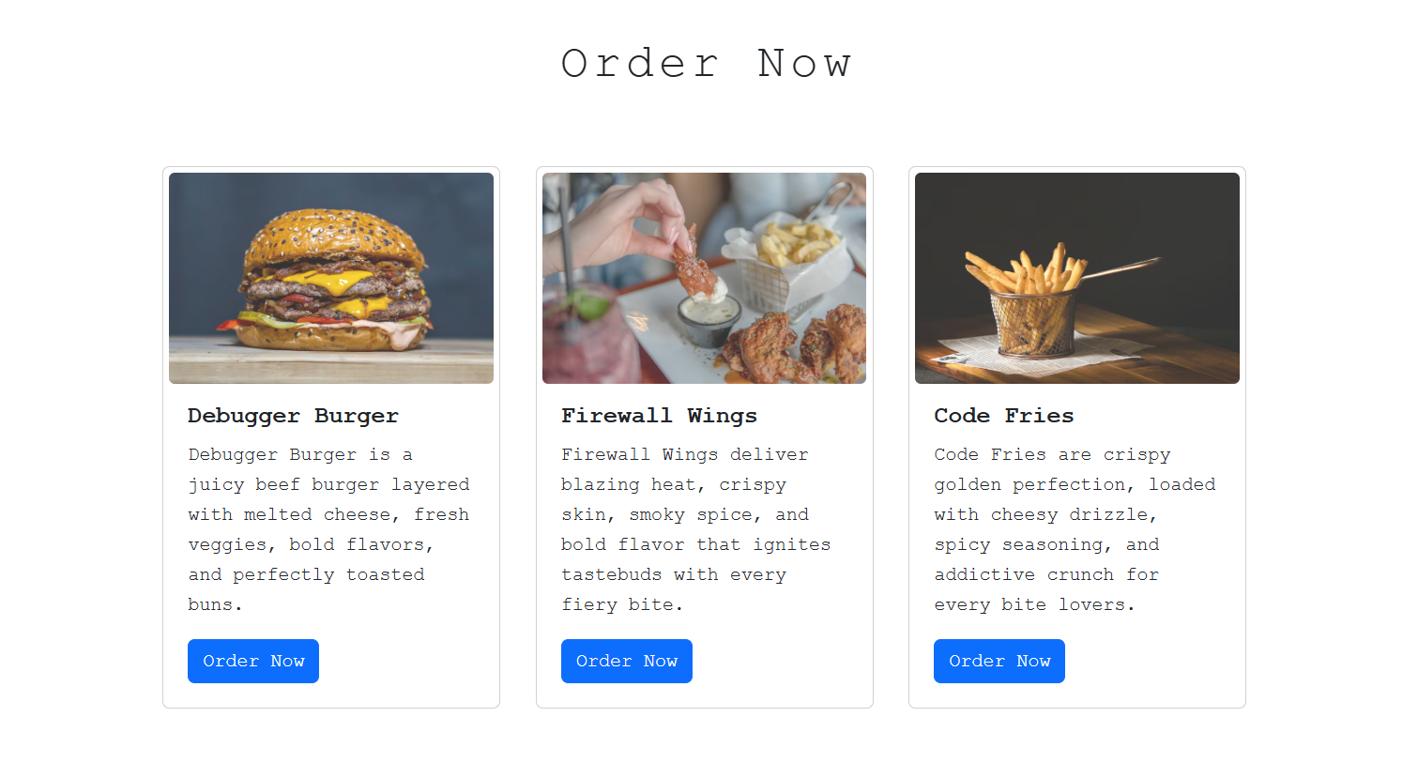Implementation of a simple contact form for customer inquiries.

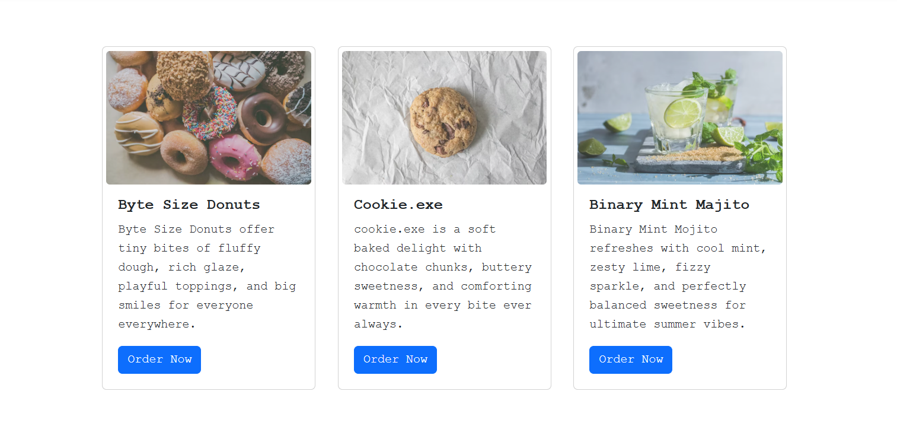

**Site Structure & Navigation**

* **Home**
* The Home section represents the **entrance of the restaurant**.
* It welcomes visitors with an attractive food image that reflects the taste, freshness, and quality of Byte & Bite.
* This section creates excitement and encourages customers to explore the restaurant further.
* To provide a professional online presence for Byte & Bite.

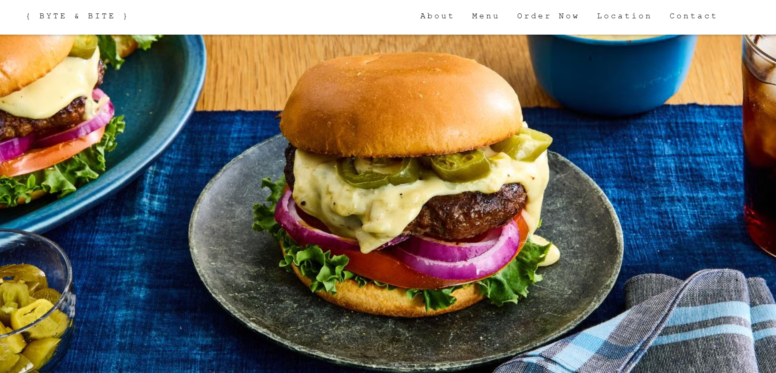

* **About**

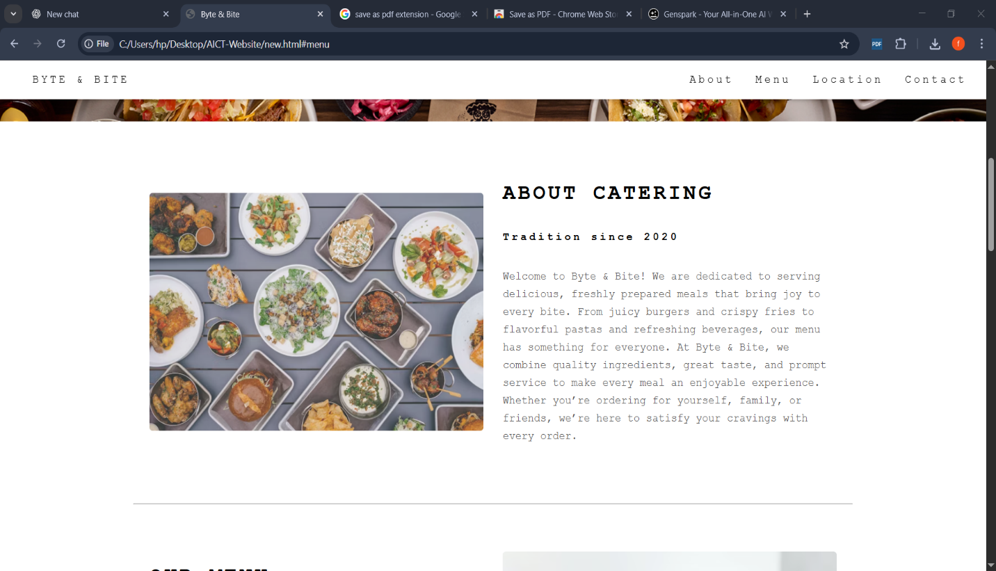The About section tells the story of Byte & Bite. It explains what kind of food the restaurant serves and how it focuses on quality and customer satisfaction. This section helps customers understand the restaurant better.

* **Menu**
* The Menu section is the **heart of the restaurant website**. It presents all food and beverage options in an organized and easy-to-read format.
* Customers can view:
* Signature and popular meals
* Desserts
* Refreshing beverages
* Special combo deals
* 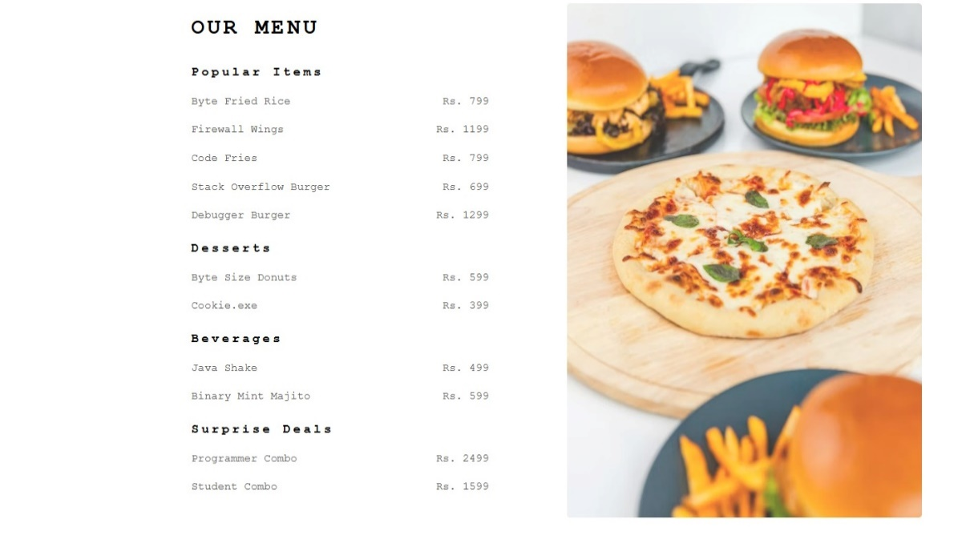Clear pricing allows customers to make quick decisions, while creative item names add personality and brand recognition.
* **Location**

The Location section gives the addresses of Byte & Bite branches. It helps customers know where the restaurant is located. Short descriptions are also given so customers can easily find the restaurant.

* **BYTE & BITE ( Branch 1 )**

**📍Near UET, G.T. Road, Baghbanpura, Lahore.**

Near UET, G.T. Road, Baghbanpura, Lahore, Byte & Bite is located in a prime and easily accessible area. Our outlet is convenient for students, families, and professionals traveling along G.T. Road or nearby areas. Drop by to enjoy freshly prepared burgers, crispy fries, pastas, and refreshing beverages in a welcoming environment

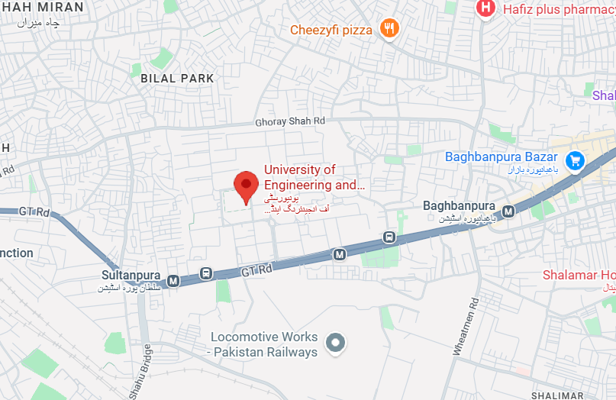

* **BYTE & BITE ( Branch 2 )**

**📍 Faisalabad Jaranwala Bypass, near Department of Textile Engineering, Chak 206 RB, Siawala, Faisalabad.**

Near the Department of Textile Engineering, Faisalabad Jaranwala Bypass, Chak 206 RB, Siawala, the Byte & Bite Taxila branch is located in a convenient and easy-to-reach area. Our outlet is ideal for students, families, and travelers passing through the bypass. Stop by to enjoy our fresh burgers, crispy fries, flavorful pastas, and refreshing beverages.

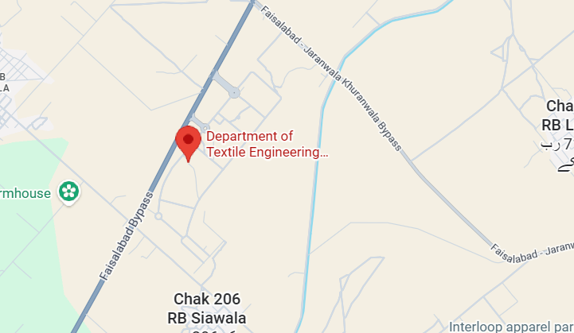

* **Contact**

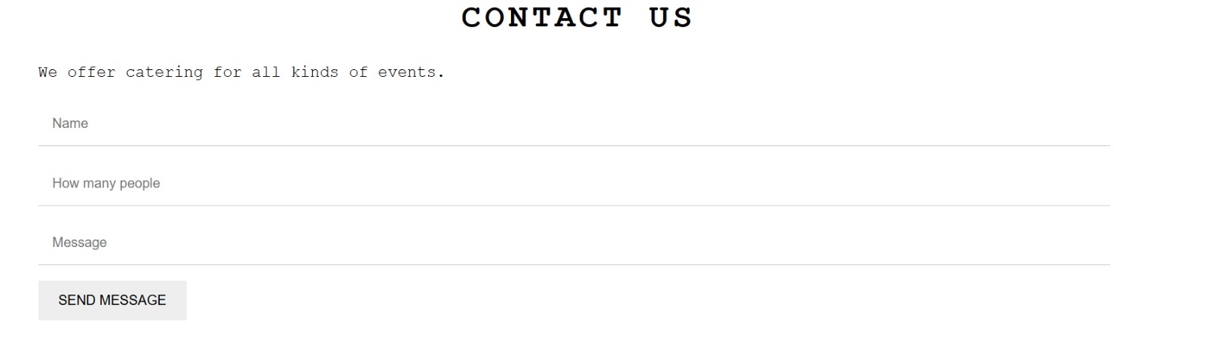The Contact section allows customers to send messages to the restaurant. Customers can ask questions or request catering services. This section helps the restaurant stay connected with its customers.

**URL: file:///C:/Users/hp/Desktop/AICT%20LAB/AICT-Website/new.html**